**AWS PROJECT – HOW TO CREATE A STATIC WEBSITE IN S3   
  
  
Harnessing the Power of AWS S3: to Static Website Hosting**

**Introduction:**

, Amazon Simple Storage Service (S3) stands out as a powerhouse for scalable and reliable object storage. Beyond its conventional use for storing and retrieving files, S3 offers a versatile feature set that extends to hosting static websites. In this blog post, we'll delve into the intricacies of S3 services and explore its potential as a robust platform for static website hosting.

**Website option for hosting Websites**

[Web Hosting - Amazon Web Services (AWS)](https://aws.amazon.com/websites/)

**Understanding Amazon S3:**

Amazon S3 is a fully managed storage service that enables you to store and retrieve any amount of data at any time. It provides a simple web interface for managing your objects and supports industry-standard protocols such as REST and SOAP. With a pay-as-you-go pricing model, S3 ensures cost-effectiveness by allowing you to pay only for the storage you consume.

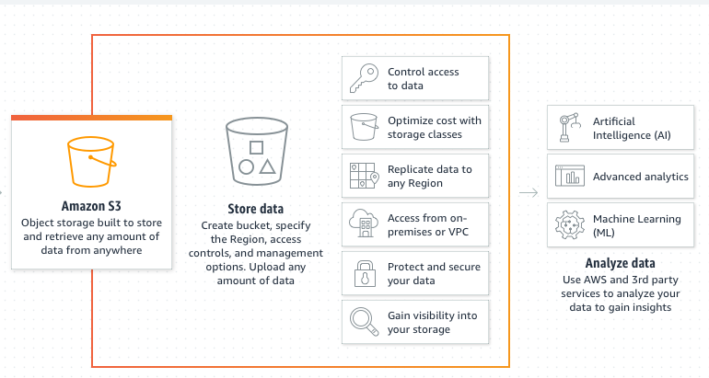

**Storage management**

Amazon S3 has storage management features that you can use to manage costs, meet regulatory requirements, reduce latency, and save multiple distinct copies of your data for compliance requirements**.**

**S3 Lifecycle** – Configure a lifecycle configuration to manage your objects and store them cost effectively throughout their lifecycle. You can transition objects to other S3 storage classes or expire objects that reach the end of their lifetimes**.**

**S3 Object Lock –** Prevent Amazon S3 objects from being deleted or overwritten for a fixed amount of time or indefinitely. You can use Object Lock to help meet regulatory requirements that require write-once-read-many (WORM) storages or to simply add another layer of protection against object changes and deletions.

**S3 Replication –** Replicate objects and their respective metadata and object tags to one or more destination buckets in the same or different AWS Regions for reduced latency, compliance, security, and other use cases.

**S3 Batch Operations –** Manage billions of objects at scale with a single S3 API request or a few clicks in the Amazon S3 console. You can use Batch Operations to perform operations such as Copy, Invoke AWS Lambda function, and restore on millions or billions of objects

**S3 Storage Classes:**

S3 offers multiple storage classes to optimize costs and performance based on your specific use case. Understanding these classes can help you make informed decisions about where to store your data. The classes include Standard, Intelligent-Tiering, Glacier, and Glacier Deep Archive, each tailored to different access patterns and durability requirements.

**Static Website Hosting with S3:**

[Hosting a static website using Amazon S3 - Amazon Simple Storage Service](https://docs.aws.amazon.com/AmazonS3/latest/userguide/WebsiteHosting.html)

One of the lesser-known but immensely powerful features of S3 is its capability to host static websites. This functionality simplifies the process of deploying and managing web content without the need for a traditional web server. Here's a step-by-step guide to setting up static website hosting on S3:

**Create an S3 Bucket:**

Log in to the AWS Management Console and navigate to the S3 service.

Click "Create Bucket" and follow the prompts, ensuring that you enable static website hosting during the setup.

Configure Bucket Properties:

Access the newly created bucket's properties.

In the "Static website hosting" section, select "Use this bucket to host a website."

Specify the index document (e.g., index.html) and error document if applicable.

**Upload Website Content:**

Upload your static website content (HTML, CSS, JavaScript, etc.) to the S3 bucket.

Ensure that the default page (index.html) and any other required files are present.

Set Permissions:

Configure bucket policies and permissions to make the content publicly accessible.

Utilize AWS Identity and Access Management (IAM) roles to manage fine-grained access control.

Configure DNS (Optional):

To use a custom domain, configure the necessary DNS settings to point to the S3 bucket's website endpoint.

Benefits of S3 for Static Website Hosting:

**Scalability:**

S3 automatically scales to accommodate varying levels of traffic and ensures high availability.

Cost-Effective:

Pay only for the storage and data transfer you use, making it a cost-effective solution for hosting static content.

Reliability:

Leverage the durability and availability of S3 to ensure the resilience of your static website.

Security:

Implement security best practices, such as bucket policies and IAM roles, to control access and secure your static content.

Conclusion:

Amazon S3 extends beyond conventional storage solutions, offering a powerful platform for hosting static websites. DevOps teams can leverage the scalability, cost-effectiveness, and reliability of S3 to streamline the deployment and management of web content.

**Policy Draft**

Amazon S3 bucket policies are typically written in JSON (JavaScript Object Notation). JSON is a lightweight data interchange format that is easy for humans to read and write, and easy for machines to parse and generate. It provides a clear and concise way to express access control rules and conditions for S3 buckets.

Here's an example of a simple S3 bucket policy written in JSON:

{

"Version": "2012-10-17",

"Id": "Policy1703151526132",

"Statement": [

{

"Sid": "Stmt1703151524030",

"Effect": "Allow",

"Principal": "*",

"Action": "s3:GetObject",

"Resource": "arn:aws:s3:::mywebsiteaseem/*",

}

]

}

**Basic HTML file**

<!DOCTYPE html>

<html lang="en">

<head>

<meta charset="UTF-8">

<meta name="viewport" content="width=device-width, initial-scale=1.0">

<title>Welcome to Cloud Aseem's Channel</title>

<style>

body {

background-color: #3498db; /* Blue background color */

color: #fff; /* White text color */

font-family: 'Segoe UI', Tahoma, Geneva, Verdana, sans-serif; /* Modern font stack */

text-align: center;

padding: 50px;

margin: 0;

}

h1 {

font-size: 2em;

margin-bottom: 20px;

}

p {

font-size: 1.2em;

line-height: 1.5;

}

a {

color: #fff; /* White link color */

text-decoration: none;

font-weight: bold;

}

</style>

</head>

<body>

<h1>Welcome to my channel - Cloud Aseem</h1>

<p>Free DevOps & Cloud knowledge - Hands-on with Real-time Projects</p>

<p>Please share & subscribe to the channel below:</p>

<a href="https://youtube.com/@clouddevopswithaseem?si=92cO5CfWnNSaTWjV" target="_blank">Cloud DevOps with Aseem</a>

</body>

</html>

Follow with the link url

http://mywebsiteaseem.s3-website.ap-south-1.amazonaws.com

`